WORLD BAND CLIMATE CHANGE ANALYSIS

**INTRODUCTION**

We have considered 10 countries for the analysis and then we have analysed how certain parameters have shown their trend for a particular country over the years. We have also done a inter-country comparison to understand the relationship between the indicators

**ANALYSIS**

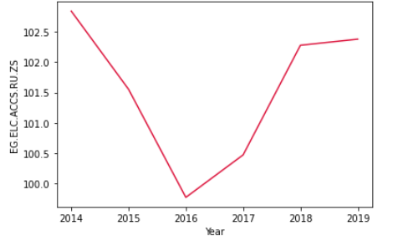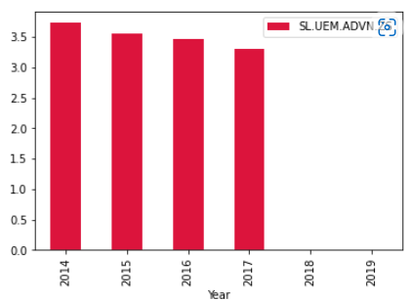

The bar graph above shows that unemployment with advanced education in Australia has shown a decreasing trend during the timeframe of 2014 to 2017

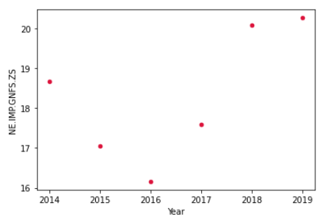

The above scatter plot shows that the total import in Pakistan has decreased from 2014 to 2016 and then increased from 2016 to 2019

The above line graph shows that the total expenditure of India has decreased from 2014 to 2016 and then increased from 2016 to 2019

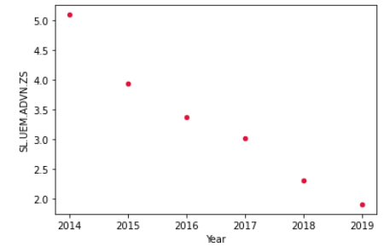

The above scatter plot shows that the unemployment with advanced education (% of total labor force with advanced education) in Bulgaria has decreased from 2014 to 2019

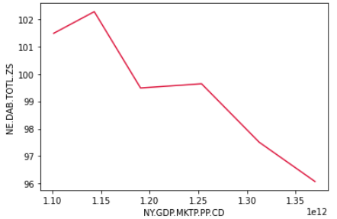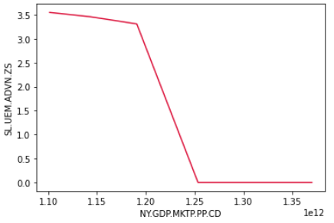

The above plot shows that for Australia there exists an indirect relationship between the purchase power parity GDP and the unemployment for advanced education %

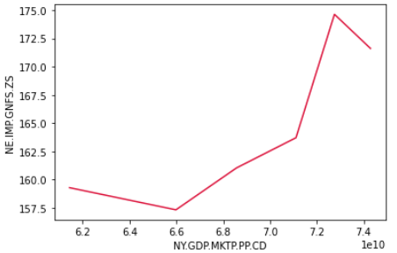

From the above line plot, it is evident that there is a direct relationship between the purchase power parity GDP and the total import of the country for Luxembourg.

**CONCLUSION**

* We could see that there is a decreasing trend for unemployment with advanced education percentage in Australia and Bulgaria from 2014 to 2019
* There is a V-shaped pattern in the line graph and the scatter plot for total import in Pakistan and the total expenditure in India from 2014 to 2019 where the least value is in the year 2016

The above line plot visualization shows that for Australia there is an indirect relationship between the purchase power parity GDP and the total expenditure of the country.

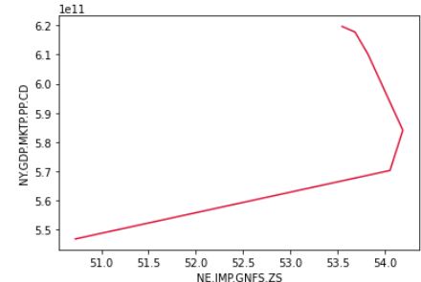

The above line plot shows that for Switzerland there is a direct relationship between the total import of the country and the purchase power parity GDP

* There exists an indirect correlation between PPP GDP and the unemployment for advanced education % for Australia and also PPP GDP and the total expenditure of Australia
* There exists a direct relationship between the PPP GDP and total import of Luxembourg and Switzerland